

LICENSURE EXAMINATION FOR PROFESSIONAL TEACHERS
SEPTEMBER 20, 2026

GURONG PINOY: PROFESSIONAL EDUCATION REVIEWER
(Session 9: May 18, 2026)

1. What is the primary purpose of the Professional Regulation Commission (PRC) in the Philippines?
- To provide scholarships to aspiring teachers
- To regulate and supervise the practice of professions in the Philippines
- To develop the national curriculum for basic education
- To accredit private schools and universities

RA 7836, “The Philippine Teachers Professionalization Act of 1994” provided for the
professionalization of teaching under the PRC. In August 1996, the Board and the PRC
administered the Licensure Examination for Teachers (LET) for the first time.

2. What is the term used for the process by which a teacher reflects on their own teaching practices to improve student learning outcomes?
- Peer evaluation
- Summative assessment
- Reflective practice
- Diagnostic testing

- Peer evaluation- by colleagues
- Summative assessment- done after instruction to check quality of learning
- Diagnostic testing- done before instruction to identify students’ strengths and weaknesses

3. According to Bloom's Taxonomy, which cognitive level involves breaking down information into its component parts?
- Analysis
- Evaluation
- Synthesis
- Application

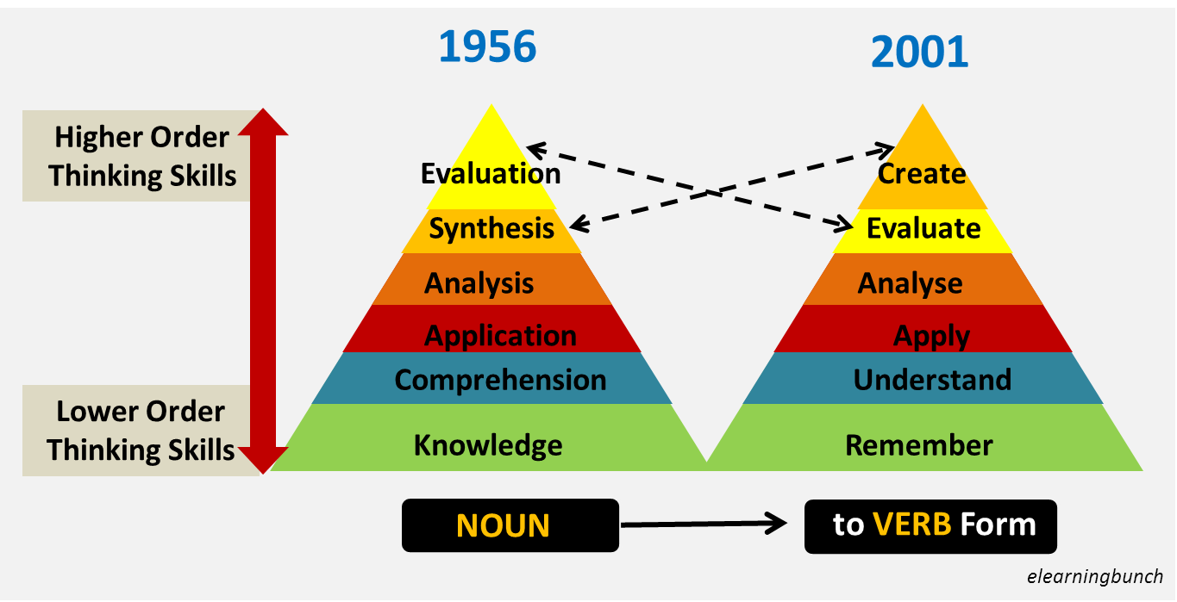

BENJAMIN BLOOM – LORIN ANDERSON
REVISED BLOOM’S TAXONOMY (COGNITIVE LEVELS: RUAAEC)
Cognitive Level | Description (Definition for LET Exam) | Common LET Action Verbs | Example LET Test Task
1. Remembering | Retrieving, recognizing, or recalling factual information, terms, and basic concepts from long-term memory. It is the lowest level of learning. | Define, list, recall, name, identify, state, memorize, recognize | "What is the capital of the Philippines?" or identifying specific dates in history.
2. Understanding | Constructing meaning and grasping the concept. It goes beyond rote memorization by allowing a student to explain, interpret, or summarize ideas. | Explain, summarize, interpret, classify, discuss, paraphrase | Summarizing the main theme of a story or explaining a teaching theory in your own words.
3. Applying | Using information, rules, or procedures in new, concrete, and real-life situations. It is about putting knowledge into practice. | Apply, execute, implement, solve, use, compute, demonstrate | Calculating a student's final grade using a specific formula or applying a psychological theory to a classroom management problem.
4. Analyzing | Breaking information down into its component parts to understand how they relate. It involves examining, categorizing, and finding evidence. | Analyze, compare, contrast, differentiate, outline, deconstruct | Comparing two different philosophies of education (e.g., Idealism vs. Pragmatism) or identifying bias in a text.
5. Evaluating | Making judgments based on criteria, standards, or values. It requires students to critique, justify, or defend a decision. | Evaluate, critique, judge, justify, defend, assess, verify | Critiquing a lesson plan based on specific pedagogical standards or defending a thesis statement.
6. Creating | The highest level in the revised taxonomy. It involves reorganizing elements into a new, original pattern, product, or idea. | Create, design, formulate, invent, compose, construct, develop | Designing a new instructional material, planning a unique research study, or writing an original poem.

4. Which of the following best describes the concept of "scaffolding" in education?
- Providing permanent support structures for students with disabilities
- Temporary support given to students to help them achieve tasks they cannot yet do independently
- A method of grouping students based on their academic performance
- A classroom management strategy for reducing behavioral issues
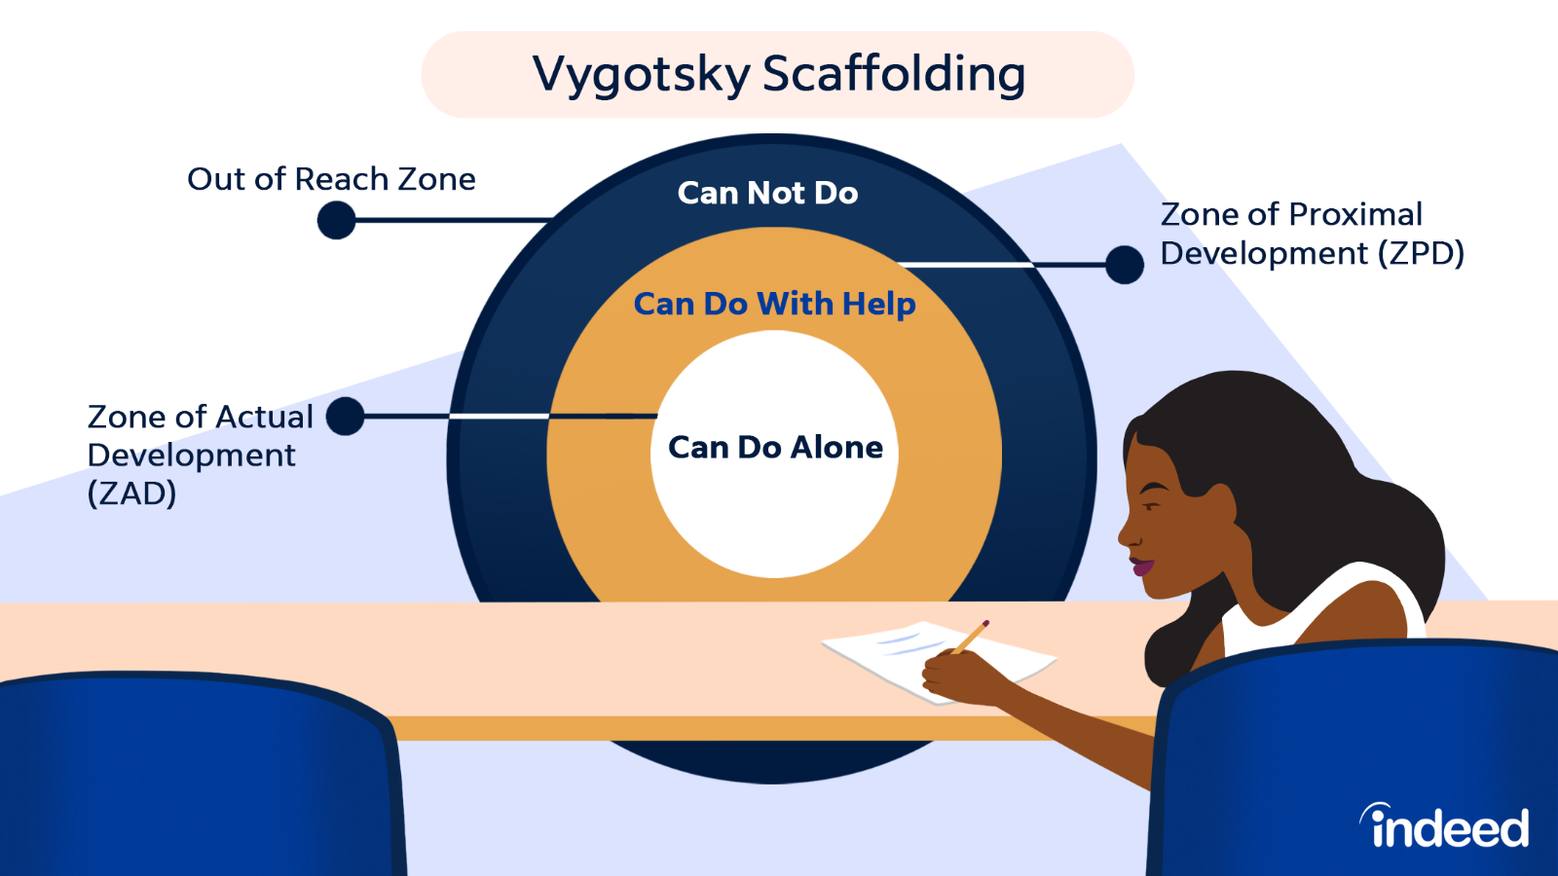

5. What does the acronym "IEP" stand for in special education?
- Integrated Educational Program
- Inclusive Engagement Protocol
- Instructional Evaluation Procedure
- Individualized Education Plan

- IEP is reviewed annually to make sure the plan fits the skills and needs of the student.
- IEP teams commonly include the regular teacher, SPED teacher, parents/guardians, school administrators, etc.

6. Which learning theory is associated with B.F. Skinner and emphasizes the role of reinforcement and punishment in shaping behavior?
  - Constructivism
  - Cognitivism
  - Humanism
  - Behaviorism

- Constructivism- learners build knowledge
- Cognitivism- mental processes
- Humanism- personal growth/self-actualization

7. A teacher notices that some students in her class learn better through visual aids, while others prefer listening to lectures. Which principle of learning does this observation reflect?
- Zone of Proximal Development
- Learning styles and individual differences
- Classical conditioning
- Mastery learning

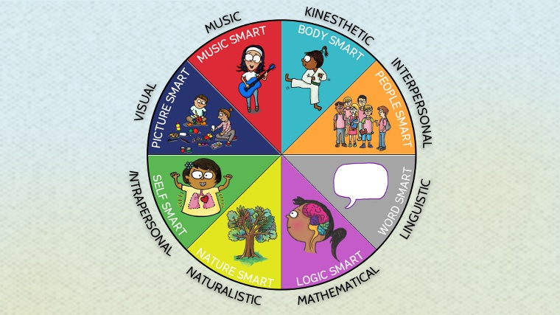
- Linguistic (Word Smart)
- Logical-Mathematical (Number/Logic Smart)
- Spatial (Picture Smart)
- Bodily-Kinesthetic (Body Smart)
- Musical (Music Smart)
- Interpersonal (People Smart)
- Intrapersonal (Self Smart)
- Naturalist (Nature Smart)

THE 8 MULTIPLE INTELLIGENCES OF HOWARD GARDNER
Intelligence Type | Simple Meaning ("Smart") | Core Ability | Ideal Classroom Activity / Assessment
1. Linguistic | Word Smart | Using words effectively in writing or speaking. | Debates, journal writing, reading stories.
2. Logical-Mathematical | Number/Logic Smart | Reasoning, calculating, and seeing patterns. | Puzzles, math drills, science experiments.
3. Spatial | Picture Smart | Visualizing things in 3D and reading maps. | Drawing, mind-mapping, charts, videos.
4. Bodily-Kinesthetic | Body Smart | Using the physical body to solve problems or create. | Role-playing, dancing, hands-on building.
5. Musical | Music Smart | Recognizing, creating, and appreciating rhythms/tones. | Creating songs, rhyming mnemonics, background music.
6. Interpersonal | People Smart | Understanding and interacting well with others. | Group work, peer tutoring, team sports.
7. Intrapersonal | Self Smart | Understanding one's own emotions, goals, and strengths. | Self-reflection journals, independent study, goal setting.
8. Naturalist | Nature Smart | Recognizing and classifying plants, animals, and nature. | Outdoor field trips, gardening, sorting specimens.

- Classical conditioning- Ivan Pavlov, bell
- Mastery learning- thru drills, used in criterion-reference tests

8. A Grade 5 teacher wants to assess whether students have truly understood a lesson on fractions and not just memorized procedures. Which assessment strategy would be most appropriate?
- A multiple-choice test on fraction definitions
- A recitation of fraction rules
- A performance task requiring students to solve real-life problems involving fractions
- A spelling quiz on fraction-related vocabulary

EDGAR DALE’S CONE OF EXPERIENCE

BREAKDOWN OF THE 11 LEVELS (FROM ABSTRACT TO CONCRETE)
Level (From Bottom to Top) | Simple Meaning | LET Classroom Example
1. Direct, Purposeful | Firsthand, real-life sensory experiences. | Cooking an actual recipe in a TLE class.
2. Contrived | Using edited copies or replicas of reality when the real thing is too big, small, or dangerous. | Using a plastic model of the human heart.
3. Dramatized | Actively participating in a reconstructed experience. | Role-playing the signing of the Malolos Constitution.
4. Demonstrations | Visual explanation of an important fact, idea, or process. | A teacher showing the step-by-step process of a science experiment.
5. Study Trips | Excursions outside the classroom to observe real events. | Visiting a local museum or a water treatment facility.
6. Exhibits | Displays of models, charts, or objects for onlookers. | Viewing projects during a school science fair.
7. Educational TV | Watching instructional television programs. | Watching an educational broadcast on Knowledge Channel.
8. Motion Pictures | Moving images that imply a sequence of events. | Watching a documentary film about World War II.
9. Audio / Still Images | Photos, recordings, or radio broadcasts with no motion. | Listening to a recorded speech or looking at a printed map.
10. Visual Symbols | Highly abstract representations of ideas. | Looking at a chalkboard drawing, chart, graph, or map sign.
11. Verbal Symbols | The most abstract level; words with no physical resemblance to the concept. | Reading a textbook chapter or listening to a lecture.

9. A teacher uses cooperative learning in her classroom. Which of the following scenarios best demonstrates positive interdependence, a key element of cooperative learning?
- Each group member is assigned a unique role, and the group's success depends on everyone fulfilling their role
- Students work individually on assignments and compare answers afterward
- The teacher assigns the same task to all groups and rewards the fastest finisher
- Students are grouped by ability level and compete against each other

10. Which of the following classroom scenarios best illustrates Vygotsky's concept of the Zone of Proximal Development (ZPD)?
- A student independently completes a math problem without any assistance
- A teacher assigns homework that students have already mastered
- A teacher guides a student through a problem the student could not solve alone, gradually reducing support
- A student memorizes multiplication tables through repeated drill

11. A teacher is planning a lesson using the ASSURE model. After analyzing learners and stating objectives, what is the next step in the model?
- Utilize media and materials
- Select methods, media, and materials
- Require learner participation
- Evaluate and revise
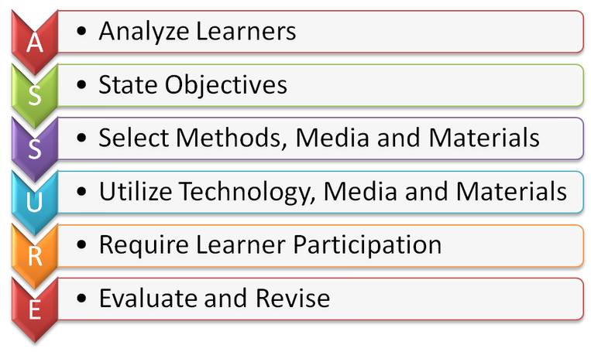

12. Which of the following best describes the difference between formative and summative assessment?
- Formative assessment is given at the end of a unit, while summative assessment is given at the beginning
- Formative assessment is graded, while summative assessment is not
- Formative assessment uses only written tests, while summative assessment uses performance tasks
- Formative assessment monitors learning during instruction to provide feedback, while summative assessment evaluates learning at the end of an instructional period

DIFFERENT TYPES OF ASSESSMENT
Assessment Type | When It Happens | Primary Purpose | Common Examples
Diagnostic | Before learning starts | Identifies baseline knowledge and gaps. | Pre-tests, skills checklists.
Formative | During the learning process | Provides ongoing feedback to adjust teaching. | Exit tickets, pop quizzes, polls.
Summative | After learning is complete | Measures overall mastery and retention. | Final exams, term papers, projects.
Benchmark / Interim | At set intervals (e.g., quarterly) | Tracks growth and predicts high-stakes outcomes. | District-wide tests, practice exams.
Criterion-Referenced | Any time | Compares performance against fixed standards. | Driver's license tests, rubrics.
Norm-Referenced | Any time | Compares performance against a peer group. | IQ tests, SATs, percentile ranks.
Ipsative | Continuous | Compares current work against past performance. | Fitness tracking, portfolio growth.
Performance-Based | During or after learning | Evaluates real-world application of skills. | Science labs, speeches, recitals.

Preposition | Educational Framework | Primary Driver | Core Purpose | Typical Methods
Assesment FOR Learning | Formative Assessment | Teacher | Guides daily instruction and fixes learning gaps. | Peer checks, feedback loop, pop quizzes.
Assessment AS Learning | Metacognitive Practice | Student | Builds self-reflection and personal goal-setting. | Rubrics, self-grading, learning journals.
Assessment OF Learning | Summative Assessment | Evaluator/Admin | Certifies milestones, assigns grades, and measures final mastery. | Final exams, standardized testing, unit projects.
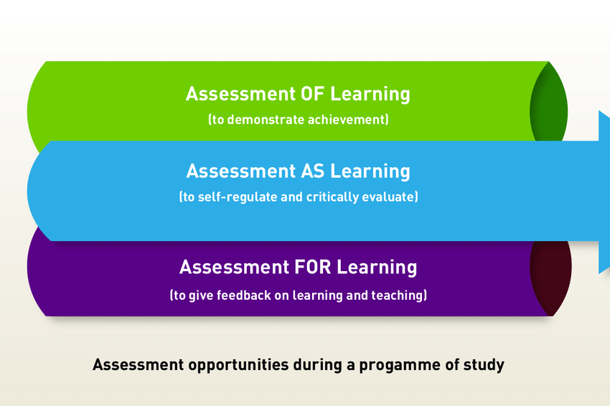
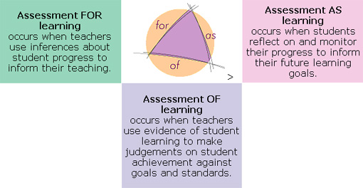

- FOR- ForT, teachers, formative assessment
- OF- X is for exam
- AS- Ako, Self

13. A teacher applies Jerome Bruner's spiral curriculum in designing her lessons. Which of the following practices best reflects this approach?
- Teaching a concept once and moving on to a completely new topic
- Grouping students by ability and teaching each group different content
- Revisiting the same concepts across grade levels with increasing complexity and depth
- Using only discovery learning for all subject areas

Bruner's spiral curriculum is an educational design framework where students revisit the same core topics multiple times throughout their schooling, with each return increasing in complexity, depth, and sophistication.

Bruner’s Three Modes of Representation: Bruner argued that learners process information in three distinct stages. It starts as enactive (hands-on, concrete actions), moves to iconic (visual images, charts, and summaries), and finishes as symbolic (abstract language, codes, formulas, and logic). A spiral curriculum moves students through these exact modes over time.

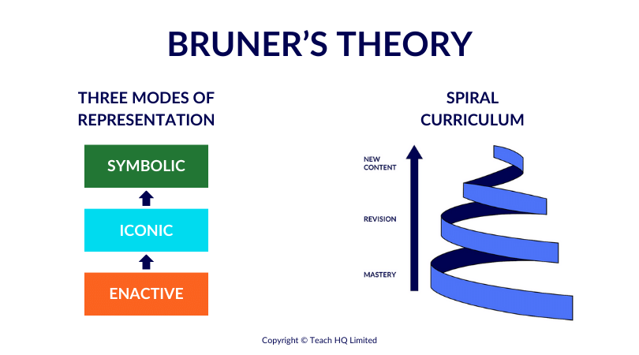

Bruner's Stage | Mode of Representation | What It Means | Spiral Curriculum Integration | Real-World Example (e.g., Fractions)
Stage 1 | Enactive | Hands-on, physical, and concrete actions. | The first loop of the spiral uses tactile objects to introduce basic ideas. | Cutting a physical apple into four equal slices.
Stage 2 | Iconic | Visual images, charts, and mental summaries. | The next loop replaces objects with drawings to show concepts visually. | Looking at a picture of a circle split into four colored quadrants.
Stage 3 | Symbolic | Abstract language, codes, and math formulas. | The final loops use formal systems to handle complex, abstract thinking. | Writing out the mathematical equation.

14. A high school teacher observes that despite using varied instructional strategies, a significant number of students consistently underperform in her class. She decides to investigate the root cause before making any changes. Which of the following represents the most strategic and evidence-based approach to address this problem?
- Immediately adopt a new teaching methodology recommended by a colleague
- Conduct a diagnostic assessment, analyze results, identify learning gaps, and design targeted interventions based on findings
- Refer all underperforming students to the guidance counselor
- Increase the frequency of quizzes to motivate students to study harder

15. A teacher is designing a unit plan for a diverse classroom that includes students with learning disabilities, gifted learners, and English language learners. Using the principles of Universal Design for Learning (UDL), which of the following approaches best addresses the needs of all learners?
- Create separate lesson plans for each type of learner and teach them in isolated groups
- Focus instruction on the average learner and provide remediation only when students fail
- Provide multiple means of representation, action and expression, and engagement to ensure all students can access and demonstrate learning
- Use a single standardized assessment to measure all students' understanding equally

16. A teacher is evaluating two instructional approaches for teaching critical thinking. Approach A uses direct instruction with structured notetaking, while Approach B uses problem-based learning with open-ended tasks. Based on educational research and learning theory, which approach is more likely to develop higher-order thinking skills, and why?
- Approach A, because structured notetaking ensures students retain all necessary information before thinking critically
- Approach B, because open-ended tasks are easier for students and reduce cognitive load
- Approach A, because direct instruction is the most efficient method for all types of learning outcomes
- Approach B, because problem-based learning engages students in authentic, complex tasks that require analysis, evaluation, and synthesis

17. A school implements a new reading program, and after one semester, test scores show minimal improvement. The principal asks teachers to evaluate the program's effectiveness. Which of the following represents the most comprehensive and strategic
evaluation process?
- Survey students about whether they enjoyed the reading program
- Compare pre- and post-test scores, analyze classroom observations, review student work samples, and gather feedback from teachers and students to make data-driven recommendations
- Discontinue the program immediately since test scores did not improve significantly
- Continue the program for another semester without any modifications and reassess

18. A teacher is planning a lesson where students must design a community project that addresses a local environmental issue. The teacher wants to align this task with higher-order thinking skills and authentic assessment principles. Which of the following best justifies why this task qualifies as an authentic assessment?
- It requires students to memorize environmental facts and reproduce them in a written test
- It is easy to grade using a standard answer key, ensuring objectivity
- It engages students in a real-world, meaningful task that requires them to apply knowledge, collaborate, make decisions, and present solutions to genuine problems
- It focuses on a single subject area, making it easier to assess specific content knowledge

19. A veteran teacher mentors a beginning teacher who struggles with classroom management. The beginning teacher relies heavily on punitive measures, which has created a tense classroom environment. Using your knowledge of classroom management theories and ethical teaching practices, which of the following recommendations would be most effective and professionally sound?
- Advise the beginning teacher to increase the severity of punishments to establish authority more quickly
- Recommend that the beginning teacher focus solely on academic instruction and ignore behavioral issues
- Suggest that the beginning teacher request a transfer to a different class with fewer behavioral challenges
- Guide the beginning teacher to establish clear, consistent, and positive classroom routines, build relationships with students, use proactive strategies, and apply logical consequences rather than punitive measures

20. During a field study in a rural school in the Philippines, a teacher observes that students are highly engaged when lessons incorporate local culture and traditions. What educational principle does this observation highlight?
- Contextual learning
- Constructivism
- Standardized testing
- Behaviorism

21. In a teaching internship, a student teacher is required to create lesson plans that align with the K to 12 curricula in the Philippines. Which of the following is a key component of this curriculum framework?
- Standardized assessments only
- Emphasis on rote memorization
- Focus solely on academic subjects
- Integration of 21st-century skills and competencies

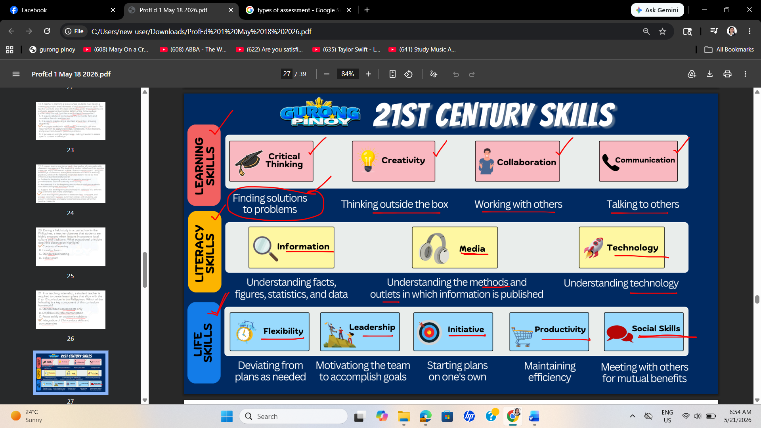

22. As part of a teaching internship, a student is tasked with conducting a community need
assessment. Which of the following methods would be most effective for gathering relevant
data?
- Relying on anecdotal evidence from fellow interns
- Distributing a survey to parents and community members
- a literature review of educational theories
- Observing classroom behavior without engaging with the community

23. Which school of thought/theory does Maslow fit into?
- Humanism
- Cognitivism
- Andragogy
- Behaviorism

- Cognitivism- thinking processes
- Andragogy- adult learning
- Behaviorism- observable behavior

MASLOW’S HIERARCHY OF NEEDS
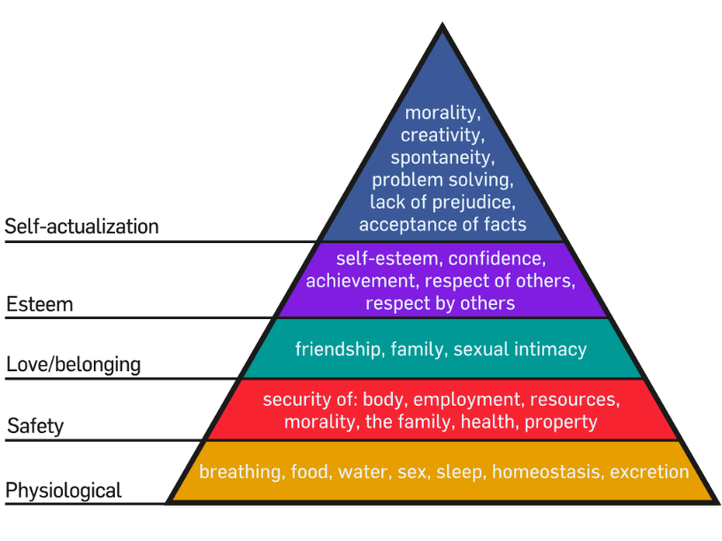
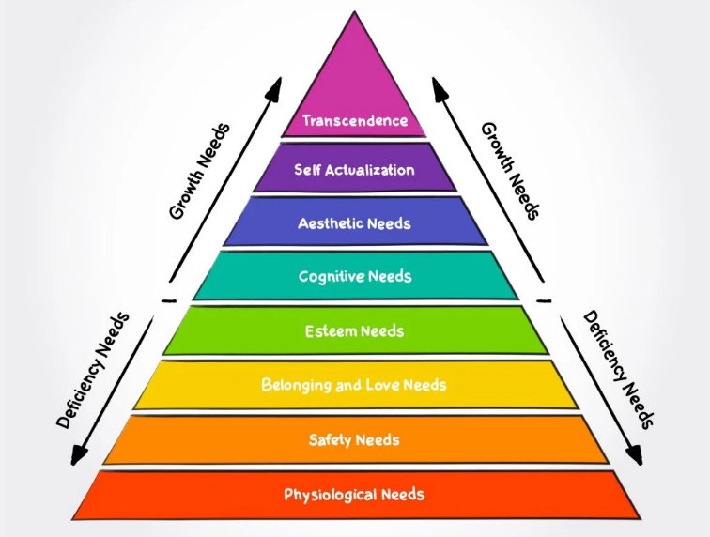

24. This theorist developed the idea of the ZPD and the need for an MKO
- Vygotsky
- Skinner
- Thorndike
- Piaget

- ZPD- Zone of Proximal Development
- MKO- More Knowledgeable Other
- Operant Conditioning- rewards and punishment
- Laws of Learning- Thorndike’s Law of Learning: Readiness, effect, exercise (TREE)
- Cognitive Development Theory – Piaget’s SPCF, Sensory, pre-operational, concrete, formal

B.F SKINNER’S OPERANT CONDITIONING QUADRANT
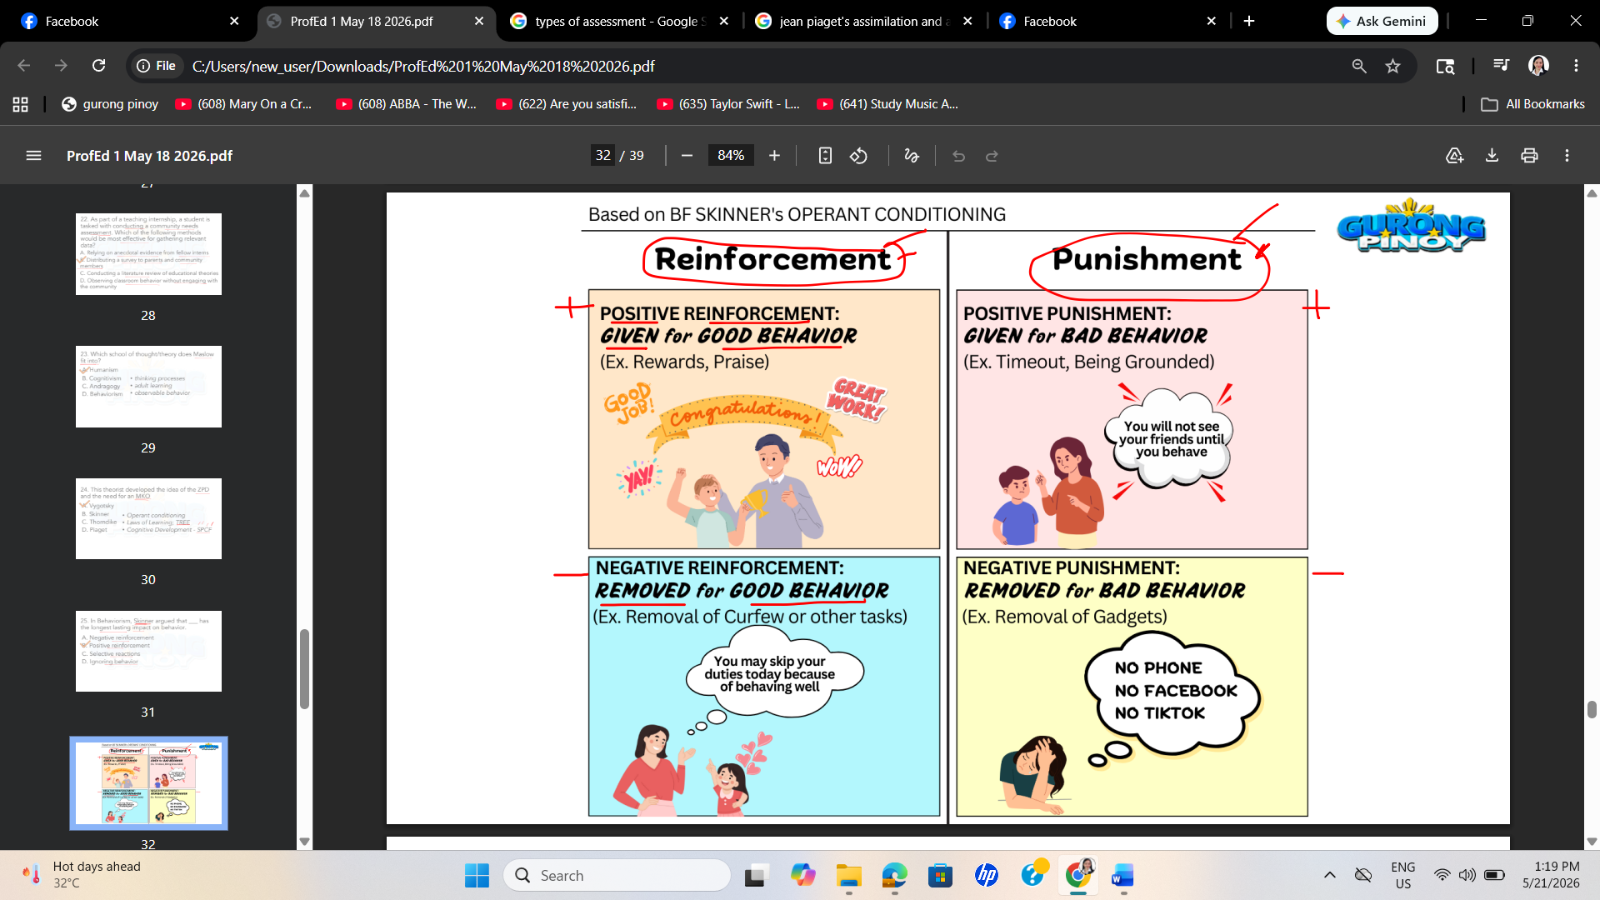

THORNDIKE’S LAW OF LEARNING
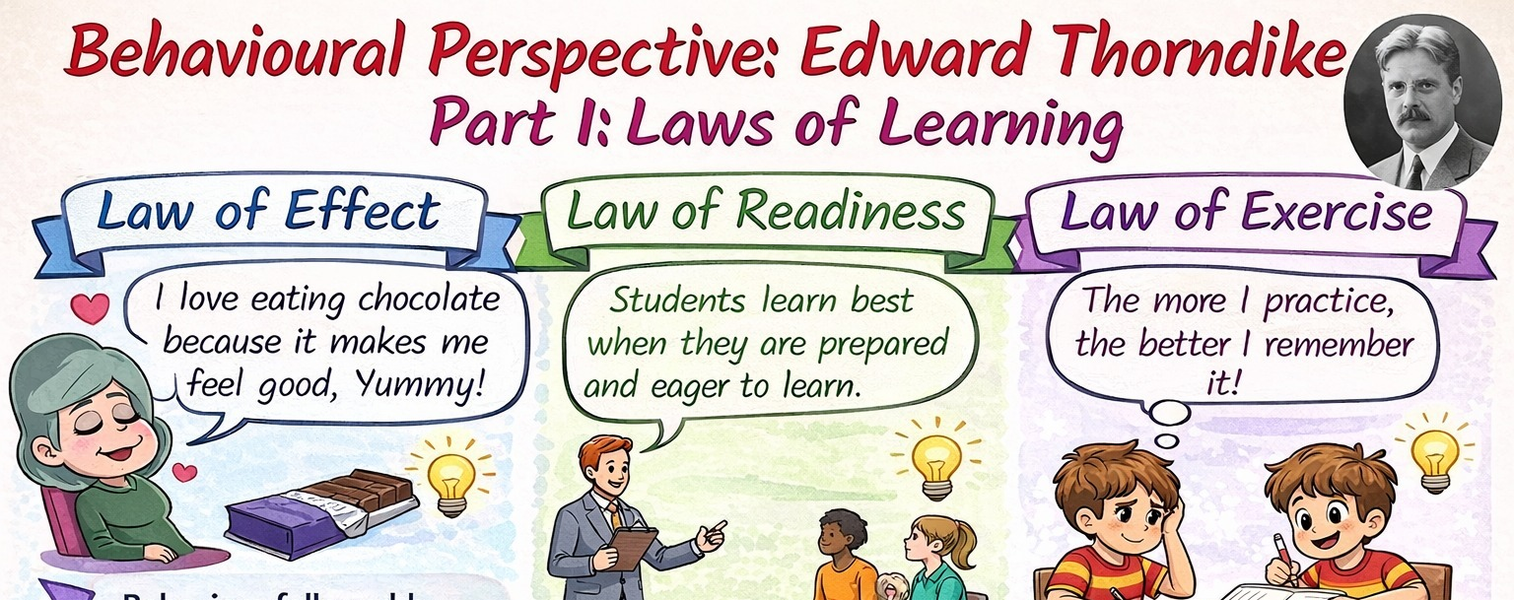

JEAN-PIAGET
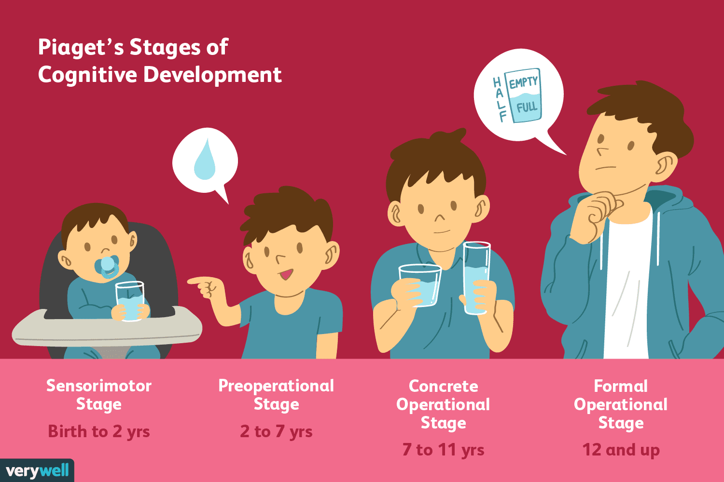

The Four Stages of Cognitive Development
Stage | Approximate Age | Core Characteristic
1. Sensorimotor | Infancy (Birth–2 years) | Experiencing the world through senses and physical actions.
2. Preoperational | Toddler/Early Childhood (2–7 years) | Thinking symbolically using language but lacking logical reasoning.
3. Concrete Operational | Elementary School (7–11 years) | Thinking logically about physical, concrete objects and events.
4. Formal Operational | Adolescence to Adulthood (11+ years) | Thinking systematically about abstract concepts and hypothetical ideas.

Piaget explained that children organize their knowledge into mental building blocks called schemas (frameworks for understanding things).

- Assimilation: Fitting new information directly into an existing schema. (e.g., A child sees a raccoon for the first time and calls it a "cat" because it has fur and four legs).

- Accommodation: Modifying an existing schema or creating a completely new one because the old framework does not fit the new information. (e.g., Realizing the animal does not meow, has a masked face, and acts differently, so they create a new "raccoon" category).

- Equilibrium: The state of mental balance when a child's schemas match up perfectly with the real-world environment around them. When a contradiction happens, they enter disequilibrium (frustration), which forces them to learn and adapt.

25. In Behaviorism, Skinner argued that ___ has the longest lasting impact on behavior.
- Negative reinforcement
- Positive reinforcement
- Selective reactions
- Ignoring behavior

26. This theory argues that all new knowledge is built on pre-existing knowledge.
- Cognitivism
- Behaviorism
- Constructivism
- Humanism

27. One of the constraints in the application of ICT for the enhancement of standards among teachers and students is ______.
  - training of technology teachers
  - connectivity of the school
  - availability of qualified teachers
  - lack of awareness about the use of technology

28. The ICT competency standards for teachers include all the following EXCEPT one. Which one?
- enhance financial literacy skills
- digital and non digital technology
- ethical issues on the use of ICT
- use of technology tools

29. A law-making body like the congress, the senate, or a university/school can recommend
academic program deemed necessary for national identity & security.
- Recommended Curriculum
- Assessed Curriculum
- Written Curriculum
- Hidden Curriculum

TYPES OF CURRICULA
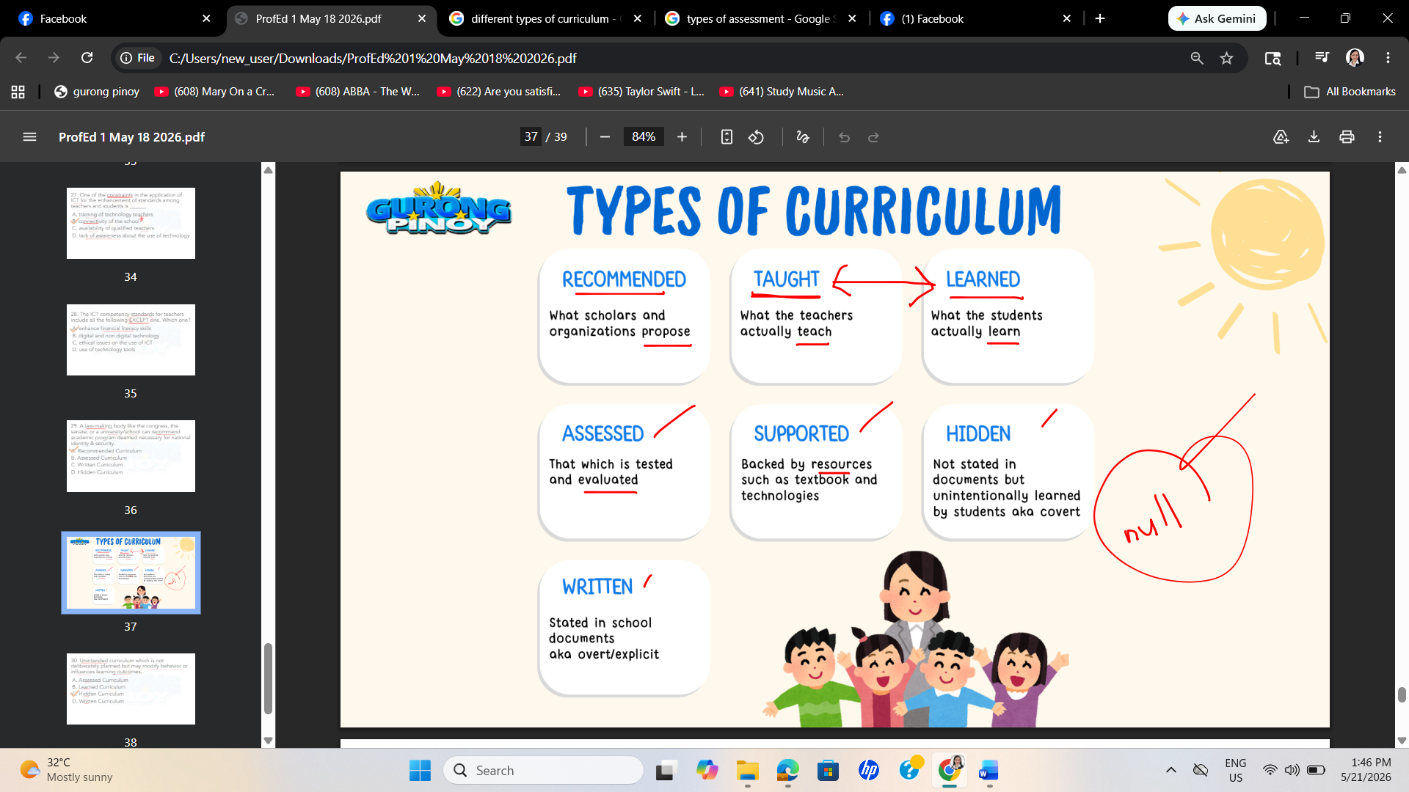

Curriculum Type | Who Controls It? | Primary Purpose | Real-World Component
Recommended | Government / Policy Makers | Sets national standards and goals. | National educational policies, CHED memos.
Written | School Admins / Authors | Structures the courses and materials. | Course syllabi, official textbooks, lesson plans.
Taught | Classroom Teachers | Implements the actual daily lessons. | Lectures, classroom experiments, group work.
Tested | Evaluators / Exam Boards | Evaluates student mastery levels. | Standardized tests, midterms, performance rubrics.
Learned | Individual Students | Absorbs and retains the information. | Changes in student capability, lifelong habits.
Hidden | Institutional Culture | Teaches social norms and behaviors. | School rules, reward structures, social setups.
Null / Excluded | Society / Time Constraints | Reflects what a culture or school deems unnecessary. | Omitted history topics, skipping sex education.

30. Unintended curriculum which is not deliberately planned but may modify behavior or influences learning outcomes.
- Assessed Curriculum
- Learned Curriculum
- Hidden Curriculum
- Written Curriculum

